Fourier Components of the Output voltage ripple Vo
Buck
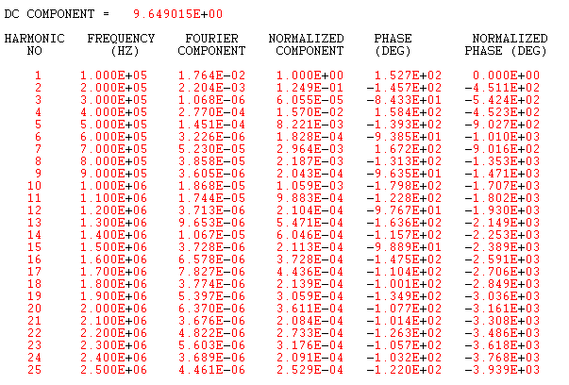
Boost
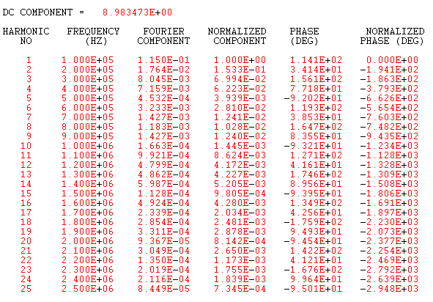

Buck Converter
(before ESR change)

(after ESR change)

Boost Converter
(before ESR change)

(after ESR change)

Boost converter after changing Duty Cycle D (0.4 -> 0.3)
Boost converter after changing duty cycle D = 0.999

