Pspice Lab 7
3.
Simulated components
”Real components”
Spiking at DT

Nominal Power Losses
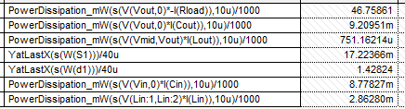
”Real” power losses
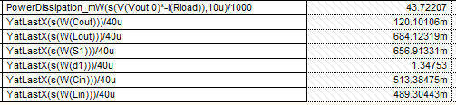

4.
Waveforms at 600kHz
Component power losses at 600kHz
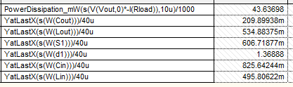

6.
Resulting Temperatures
In ”steady state”, Tj = 25,8C, Tc = 25,28C, Ts = 25,14C
7.
Resulting Temperatures
In ”steady state”, Tj = 62,61C, Tc = 62,06C, Ts = 61,92C
At 5ms the temperature goes from steady state to a gradual increase until it reaches a new steady state at the new power output. I essence a step response.

8.
At 1.2ms, the external voltage reference is increased in the controller. The input and output current as well as output voltage follow suit.
At 2ms the external reference voltage is “pulsed”. Due to the way that output current and output voltage both decrease simultaneously, one can conclude that the load itself has change (increased impedance). The pulse in the controller reference is the controller attempting to compensate.
At 3ms the opposite happens and the load decreases suddenly in impedance, giving a negative compensation.

