1.
a) Square Wave operation
From the plot, we can see that there are four different states in which different devices must conduct in order to accommodate different current paths. This is best illustrated using a table:
Case | Vo | Io | Conducting Device
1 | + | - | D1, D2
2 | + | + | T1, T2
3 | - | + | D3, D4
4 | - | - | T3, T4
By simply referring to the schematic and using the information of which direction the current must flow, as well as which (if any) diodes are forward biased, the conducting devices can be determined.

b) PWM operation
Determining which devices are conducting for a bipolar switching scheme is slightly more involved, as it directly synthesizes a sinusoidal signal on the output (after filtering). Since the current will lag the voltage with an inductive load, determining the current paths involves taking into account the bipolar switching in four different cases ([filtered] voltage and current both pos. or both neg., one neg. and one pos.), as well as considering when each switch pair is active. This gives a total of eight current paths, which can be determined in the same manner as for square wave operation.

Case | Vo | Io | Conducting Device | Notes
1 | - | - | T3, T4 | Vo1 neg,  Io neg
2 | + | - | D1, D2 | Vo1 neg,  Io neg
3 | + | - | D1, D2 | Vo1 pos,  Io neg
4 | - | - | T3, T4 | Vo1 pos,  Io neg
5 | + | + | T1, T2 | Vo1 pos,  Io pos
6 | - | + | D3, D4 | Vo1 pos,  Io pos
7 | - | + | D3, D4 | Vo1 neg,  Io pos
8 | + | + | T1, T2 | Vo1 neg,  Io pos

From these two modes of operation, one may conclude that the diodes conduct when the output (filtered) voltage and current have opposing polarity.

2.
Square Wave
Load Voltage
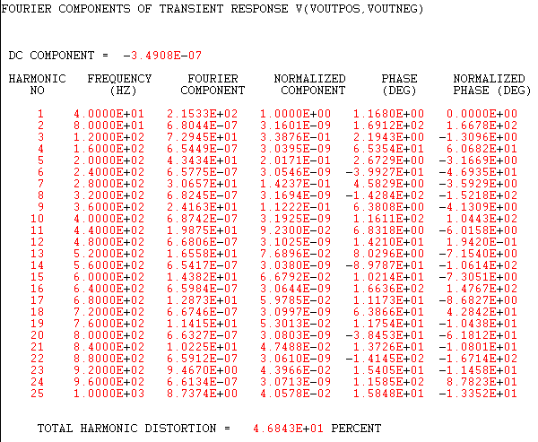
Load Current
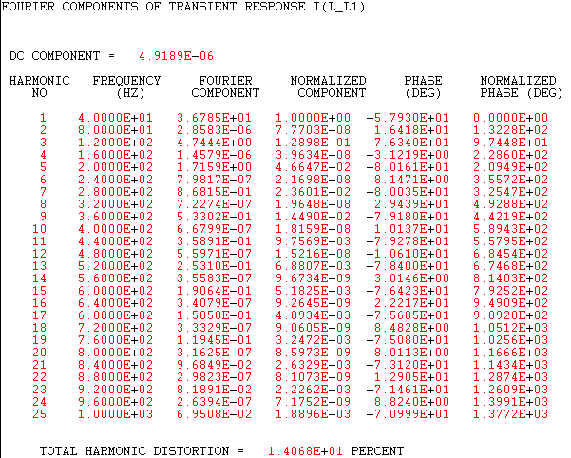
In square wave operation the harmonic components are odd and decrease linearly. The THD values for the output voltage and current are 46,8% and 14,1% respectively.

PWM
Load Voltage
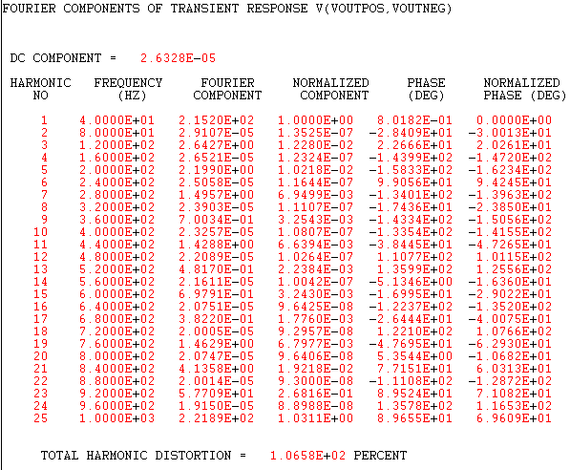
Load Current
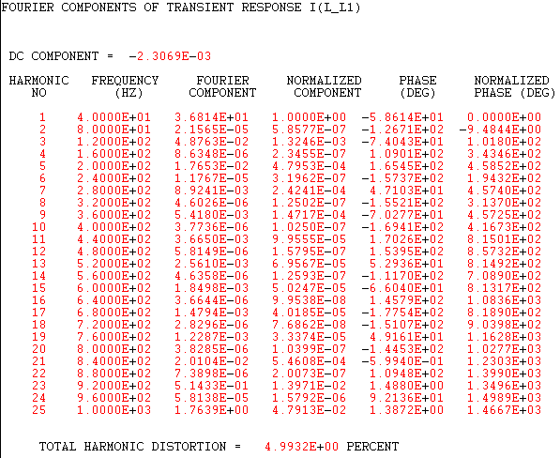
In PWM operation the significant harmonic components appear at the fundamental frequency (ie. 40Hz) and at multiples of the frequency modulation ratio(ie. mf = fs/f1 = 1000Hz/40Hz = 25) and its sidebands. The sidebands are at ±even components for odd multiples for mf and ±odd components for even multiples of mf.
From the fourier analysis above, it is clearly shown that there are significant fourier components at mf and mf±2 and mf±4.
The THD values for the output voltage and current are 106,6% and 5,0% respectively.

In summary, PWM mode has more significant harmonic components at higher frequencies than square wave operation, as well as an exceptionally high THD value on the load voltage. This may be outweighed however by a comparatively clean load current.

3.
L_out = 20mH
Red=Iout; Yellow=Vref; Purple=Vout; Pink=I_D1
L_out = 40mH
With an increase in load inductance, both the output current and current ripple are lower. The current waveform now has a THD of 4,5%, compared to 5% before.
The diode conducting time has not been affected, only phase shifted (1ms to the right).

4.
Unipolar switching is used.
Fourier Analysis
This type of switching effectively “doubles” the frequency of the dominant harmonics and associated sidebands, they now appear only at 2fs*n, thus reducing the harmonic content of the output signal significantly and resulting in a much cleaner output signal. The THD values for the output voltage and current are 58,5% and 1,4% respectively, indicating very little current ripple.
Another advantage is that the output voltage only has a range of Vd at any one time, lowering voltage handling requirements of peripheral components, such as in filters.
The largest drawback of unipolar switching is the relative control complexity; the two legs of the full- bridge inverter are controlled independently and two control signals are required. Each switch is activated at different times as seen in the waveforms below:

