Pspice Lab 6 – Single- and Three-Phase Diode rectifier
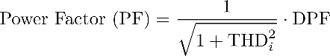
, where THDi and φ (angle between voltage and first current harmonic) can be read from FTT output.
Voltage Stiff DC-side
DPF | cos(28,8°) = 0,87
THDi | 53,7%
PF | 0,76
ΔVd (Vout ripple) | 5,67 V

Current Stiff DC-side
DPF | cos(22,9°) = 0,92
THDi | 35,8%
PF | 0,86
ΔVd (Vout ripple) | 0,56 V
Single Phase Diode Rectification
Voltage-stiff DC side
Ls = 1mH
Ls = 1nH
Current-stiff DC side
Ls = 1mH
Ls = 1nH

Three-Phase Diode Rectification
Current-stiff DC side
Nominal values
Current-stiff, Ls = 1nH

Voltage-stiff DC side
Nominal
Voltage-stiff, Ls = 1nH

