Task 1 – Genre analysis (see longer instructions on Pingpong) [FOR AUTHORS]
Note: I have distinguished between ‘authors’ and ‘reviewers’. Author means the person doing the assignment. Reviewer is for peer review and where reviewers will provide feedback (e.g. on the author’s data commentary)
Example 1 (copy paste a screenshot or equivalent below of your first data commentary example)
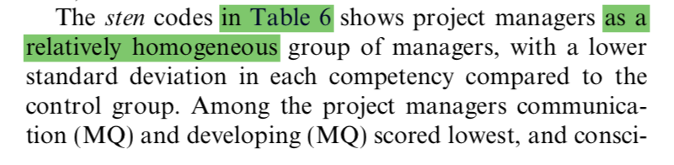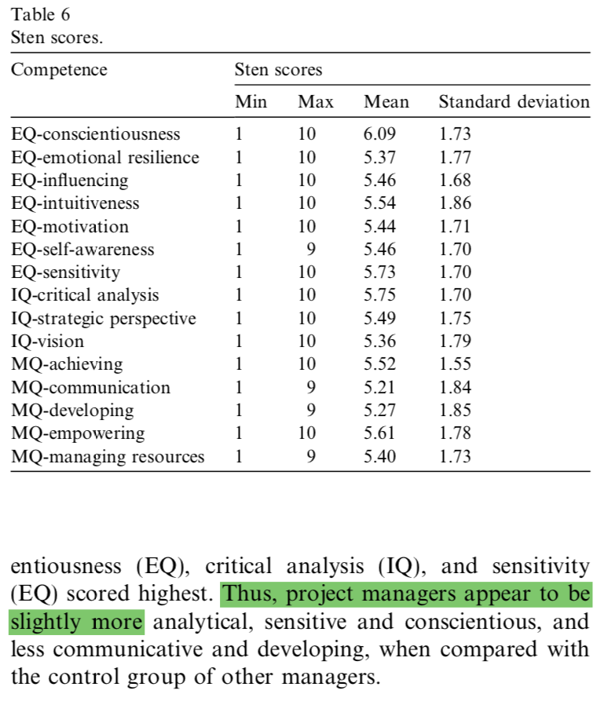

Reflection
Address the following:
- Is there a clear purpose with the visual? Why/why not?
There is a clear purpose to summarize the results of a questionnaire with standardized STEN scores.

- Is the data commentary (visual + text) typical for your discipline? Why/why not?
Showing statistical data in tables is typical for the computer science discipline but also for every other discipline.

- Is the data commentary effective? Why/why not? Essentially, how effective is this piece of communication? What would you change?
In my opinion the data commentary is effective because it highlights the maxima and minima and summarizes the findings of the table. In addition, using standardized results makes the data easier accessible for the reader.

Example 2 (copy paste a screenshot or equivalent of your second data commentary example below)
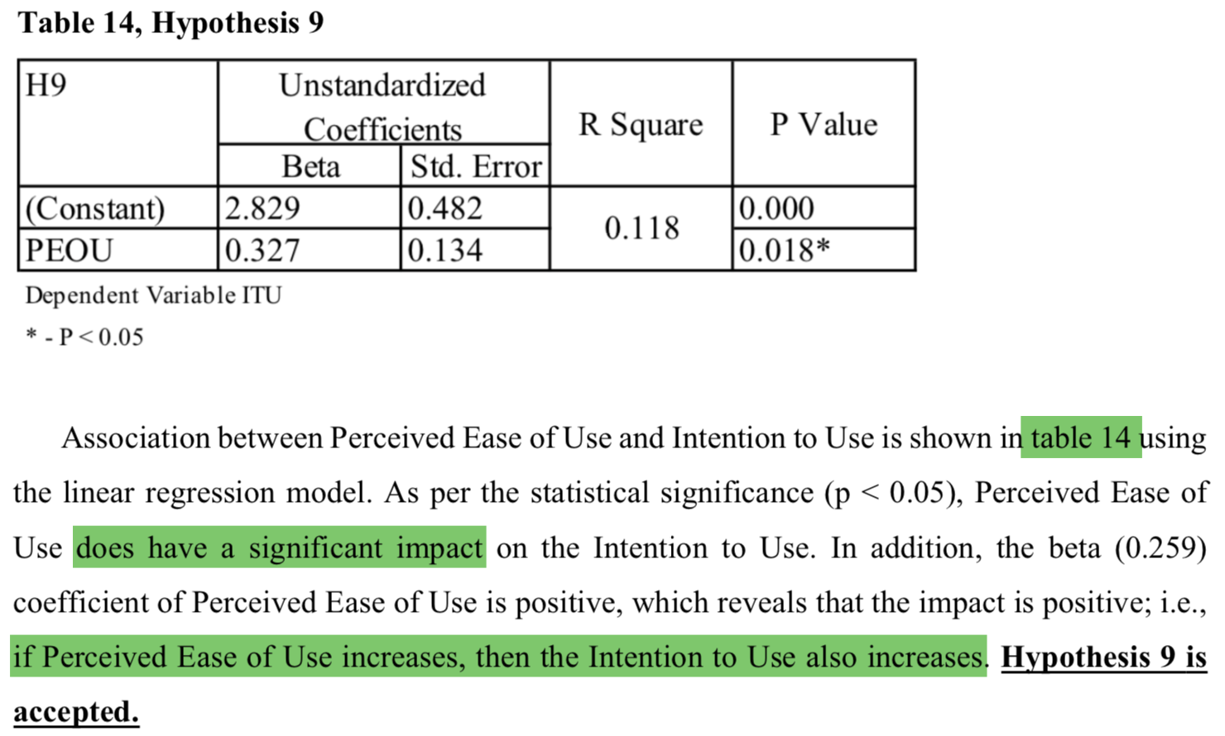

Reflection
Address the following:
- Is there a clear purpose with the visual? Why/why not?
There is the clear purpose to present and interpret the statistical findings showed in the table to answer a research question (hypothesis)
- Is the data commentary (visual + text) typical for your discipline? Why/why not?
Presenting statistical data in tables is common.
- Is the data commentary effective? Why/why not? Essentially, how effective is this piece of communication? What would you change?
First of all, the text references values that are not present in the table making it confusing. Besides that, it gives a good interpretation of the important statistical values and concludes the commentary with not rejecting the research hypothesis.

Task 2 – Your data commentary [FOR AUTHORS]
Write a data commentary relevant to your field of study.

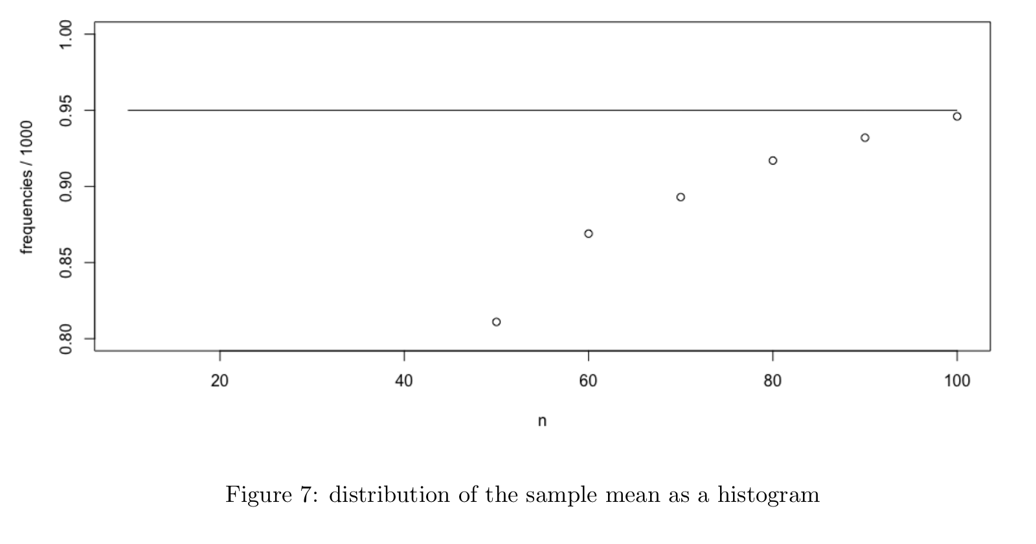
In figure 7 we can see the frequencies that the confidence interval included the theoretical mean
for each sample size between 0 and 100. We can see that for n = 100 the true mean was included
almost 95%. With n = 80 and n = 90 it was around 90%. The relative frequency for lower sample
sizes is lower than as expected from a 0.95 confidence level. In addition, the values are lower to
than those obtained by non-parametric bootstrap. This could be due to the approximated distribution
parameters.

- Choose a diagram, a graph, a table or similar which you preferably will need to use for a writing project in one of your technical courses.
- Introduce and comment the data according to the guidelines provided by Swales and Feak (unit 4) (approx. 150-250 words).

Task 3: Peer review fun! [For REVIEWERS to complete]
[Reviewers: John Croft]
This is where your peers get to provide you with some detailed feedback.
Step 1: Investigation
Skim through your partner’s text.
Comment here on your overall impression of the data commentary. Is it effective? (You do not have to back up this type of immediate impression.)
The data commentary is moderately effective. The first half of the text unfortunately focuses on reiterating the contents of the graph, without much in the way of commentary. These highlighted data points do not receive any further discussion.
The latter half improves things by making relevant comparisons and concluding with a hypothesis.
The graph itself perhaps a little bare-bones and cannot be understood without the aid of the text.
Graph comments:
- “Sample size between 0 and 100…” not consistent with diagram. The n-axis seems to start at >0.
- No legend. What does the line represent? The datapoints?
- Axes seem lacking. Not incorrect, but uninformative. “n” is implicitly assumed to be sample size, though the connection is not made explicit in either the graph or the text.
- Much of the graph is empty. There is no data in the range n=[0,40], and should probably be omitted (unless, of course, the lack of data in this range is significant in itself).

Step 2: critical reading and reviewing
Write an introductory paragraph on your partners Data commentary where you:
Describe what you experience as the focus of the text, in your own words.
The text focuses on highlighting specific parts of the graph and emphasizing discrepancies with other data, as well as forming a hypothesis as to the cause.
Talk about what you see as the overall purpose or idea expressed in the text.
See above.
Describe how you experience the overall structure of the text draft.
The structure follows the typical locate-highlight-discuss-conclude structure. This is exactly what the reader expects.

Then, start commenting on the text:
This can either be written here, or you can use the comment function and include comments on the previous page. Up to you!
- Look for structural features and describe what YOU see. Use the linguistic markers/language you've encountered in your reading, i.e. location + indicative summary / Linking as-clause and highlight / implications.
- Comment on elegant formulations (parts you like/appreciate/think are effective) and look for formulations that are confusing to YOU.
- Come up with things YOU would like to know more about.
- Use in-text comments to describe what you do not understand and point out such sections in your peer’s draft. Point out formulations you like, and formulations that are confusing. Are there claims you disagree with?
The first sentence is rather confusing and I’m not exactly sure how to interpret it. Presumably a word is missing and possibly some punctuation. The “confidence interval”: does it include the “frequencies” or does it include the “theoretical mean for each sample size”? (or both?).
“… was included almost 95%”. A very minor point, but stands out as slightly awkward. The frequency is 95% of the mean, 95% of the mean is not included in the frequency. (I might be misinterpreting the meaning, however. I’m not a statistician :> ).
Past and present tense are mixed.
The last three sentences are effective

Task 4: Revised data commentary + reflections [FOR AUTHORS]
- Revise your text here, taking into account the feedback you’ve received and your overall learning.
(Add your revised visual + text here, NOT earlier in the document)
- Address the following reflection points:
- How did you interpret the feedback you received?
- What changes did you make, and why?
- What feedback did you not take into account, and why? (assuming there is some feedback which you didn’t act on)
- Briefly describe your main ‘takeaway’ points from this small module on data commentary. i.e. what is important for you to remember (or learn/develop) when thinking of future writing tasks.

Congrats!

You’re done

Criteria [for AUTHOR reference; for ANTHONY when assessing]

I’ve copy-pasted the criteria here. Use them to help guide your writing! I (Anthony) will comment here after your final upload.
Criteria: Data commentary
Content
Your text should:
- display progression from the 1st data commentary to the revised version.
- include the 2 genre examples + reflection, a 1st draft, peer comments, a revised version, and a final reflection (the whole assignment)
- comment the data in a relevant way.
- refer to any sources you have used. The references should be listed at the end of the text. Pictures should have a label and a reference. You should use one of the referencing systems, e.g. the Harvard style.
- be approximately 150-250 words (not including pictures, title and references). The text should be Times new roman size 12, single spaced with regular margins.
Structure
Your data commentary should:
- have a clear layout
- include a location/summary statement.
- present a few highlighting statements.
- Include a discussion (implications? Problems? Comments on validity? Etc.)
- present a useful title
- display clear paragraphing and sentence structure
- be logical and unified, for instance though appropriate use of connective linking terms.

Language

Your text should:
- communicate its message in a clear and informative way.
- be in your own words, i.e. it should not be possible to find phrases in your commentary in another text.
- display accurate use of spelling, grammar and vocabulary so that the comment is useful.
- be written in a formal, academic style.

