Task 1 – Genre analysis (see longer instructions on Pingpong) [FOR AUTHORS]
Note: I have distinguished between ‘authors’ and ‘reviewers’. Author means the person doing the assignment. Reviewer is for peer review and where reviewers will provide feedback (e.g. on the author’s data commentary)
Example 1 (copy paste a screenshot or equivalent below of your first data commentary example)
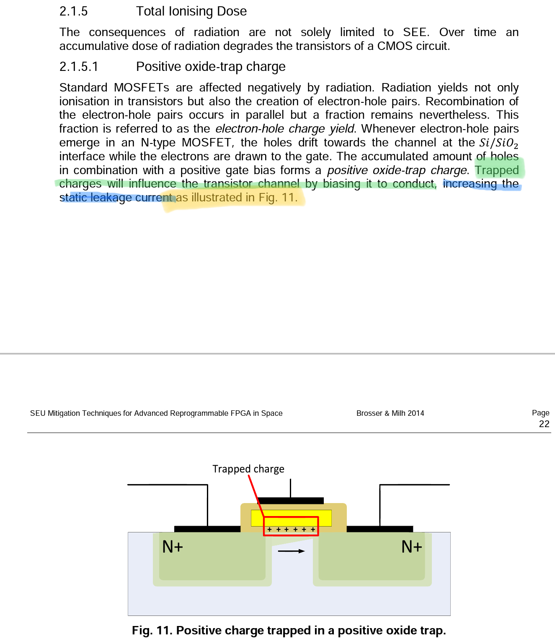
Mark down location statement(s) highlight(s) and any comparisons/implications

The highlighting statement is highlighted in green. This statement conveys a literal interpretation of the figure’s most important aspect: that a charge trapped in the transistor channel will cause it to conduct. This leads into an implication (highlighted in blue) that is not present in the figure directly: that the increased conduction due to trapped charge will result in in a higher static leakage current. Finally, the sentence is concluded with a combined location and linking statement, in yellow, that refers the reader to the figure in question.
Reflection
Address the following:
- Is there a clear purpose with the visual? Why/why not?
The figure clearly shows the mechanism by which MOSFET transistors conduct, with the implication that trapped charge ”traps” it in its conducting state. Most EE graduates should be familiar enough with this type of transistor model to draw this conclusion. Using this type of model is also consistent with other figures in the chapter (and paper as a whole), that highlight other MOSFET phenomena. Despite this, the figure presents little new information and nothing that is not easily understandable from the text, calling into question whether a figure is actually warranted in this case.
- Is the data commentary (visual + text) typical for your discipline? Why/why not?
This type of figure is very typical. Simple images consisting of basic shapes and symbols representing well established models with some manner of highlighting over the parts of interest.
The text itself is also fairly typical, being mainly a descriptive text with relevant implications at the end. The text is economical, factual and quite terse.
- Is the data commentary effective? Why/why not? Essentially, how effective is this piece of communication? What would you change?

Example 2 (copy paste a screenshot or equivalent of your second data commentary example below)
Mark down location statement(s) highlight(s) and any comparisons/implications
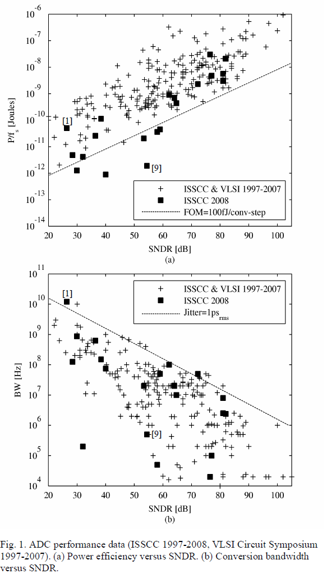
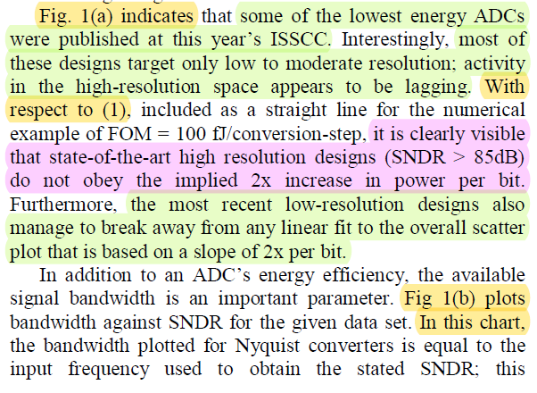
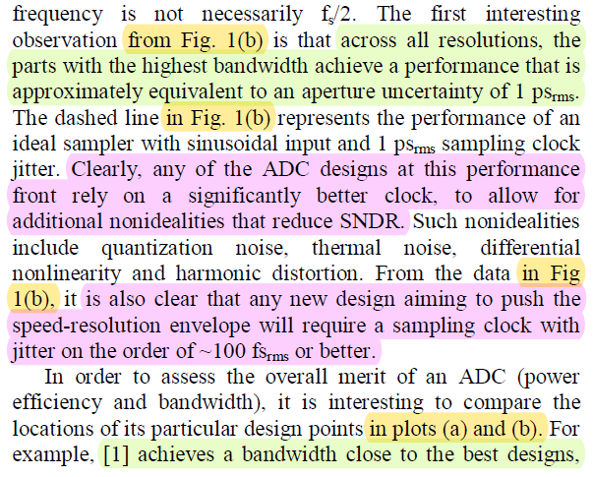
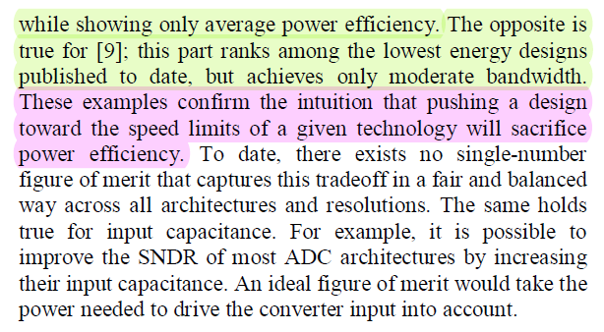
This example comes from Murmann 2017, a study on the subject of ADC trends. In this chapter, the author has compiled data on a large number of converters and plotted them in a way that offers two different perspectives. He first treats the graphs independently before going on to compare them.
Location statements are given in yellow, highlighting statement in green and discussions/implications in pink. Linking statements appear to be absent in this example, at least in the form of “As …” statements.

Reflection
Address the following:
- Is there a clear purpose with the visual? Why/why not?
The purpose of the graphs is to show trends in the data for various combinations of parameters. Namely, the inherent technological bounds and tradeoffs in the performance of modern ADCs.
- Is the data commentary (visual + text) typical for your discipline? Why/why not?
The figures are typical of this sort of data: a scatter plot with a line of best fit or other line of comparison, essentially.
The accompanying text offer no surprises; in fact, it follows a distinct pattern of referring to a particular piece of data, highlighting some relevant aspect and discussing it. The portions of the text not commenting the data are mainly factual and serve to educate the reader on relevant topics. The last paragraph also discusses the limitations (non-ideal figure of merit) of previous conclusions, which is, again, fairly typical.
- Is the data commentary effective? Why/why not? Essentially, how effective is this piece of communication? What would you change?
I believe that this is effective data commentary. The graphs are fully labeled and captioned, with no extraneous information that is not referenced in the text. The plot style is appropriate for the information being conveyed.
The article is clearly aimed at engineers familiar with ADC fundamentals, which is reflected in the jargon used throughout the text. The fundamentals are, however, sufficient to fully understand the discussions and implications; a sign of effective communication.
The text is fairly fluid, and the repeated location statements (“… fig. (b) …”), something that some authors, myself included, painstakingly try to avoid, actually help to resolve ambiguity before it interrupts the reader’s flow and train of thought.

Task 2 – Your data commentary [FOR AUTHORS]
Write a data commentary relevant to your field of study.
- Choose a diagram, a graph, a table or similar which you preferably will need to use for a writing project in one of your technical courses.
- Introduce and comment the data according to the guidelines provided by Swales and Feak (unit 4) (approx. 150-250 words).
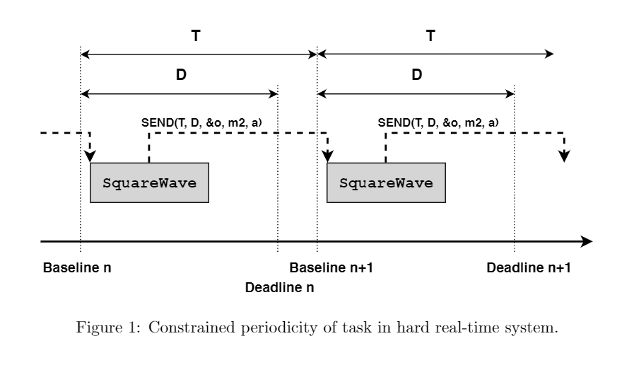
Using the reactive object programming paradigm, expressing periodically executing tasks is not quite as simple as the common looping constructs in procedural paradigms would suggest. A simple loop does not have the timing information necessary to adequately schedule subsequent events without succumbing to some form of timing skew. The way to correctly loop in the reactive paradigm, as seen in fig. 1, is to call the same method (in this case a method responsible for manipulating an object such that a square wave is produced) recursively.
The call is made asynchronously, scheduling the task to repeat at some point in the future relative to the baseline of the calling method. This has the considerable advantage of always scheduling in absolute offsets, regardless of when the call actually occurs, preserving the necessary timing information and eliminating timing drift.
Task 3: Peer review fun! [For REVIEWERS to complete]
[Reviewers: write your name here]
This is where your peers get to provide you with some detailed feedback.
Step 1: Investigation
Skim through your partner’s text.
Comment here on your overall impression of the data commentary. Is it effective? (You do not have to back up this type of immediate impression.)

Step 2: critical reading and reviewing
Write an introductory paragraph on your partners Data commentary where you:
Describe what you experience as the focus of the text, in your own words.
Talk about what you see as the overall purpose or idea expressed in the text.
Describe how you experience the overall structure of the text draft.

Then, start commenting on the text:
This can either be written here, or you can use the comment function and include comments on the previous page. Up to you!
- Look for structural features and describe what YOU see. Use the linguistic markers/language you've encountered in your reading, i.e. location + indicative summary / Linking as-clause and highlight / implications.
- Comment on elegant formulations (parts you like/appreciate/think are effective) and look for formulations that are confusing to YOU.
- Come up with things YOU would like to know more about.
- Use in-text comments to describe what you do not understand and point out such sections in your peer’s draft. Point out formulations you like, and formulations that are confusing. Are there claims you disagree with?

Task 4: Revised data commentary + reflections [FOR AUTHORS]
- Revise your text here, taking into account the feedback you’ve received and your overall learning.
(Add your revised visual + text here, NOT earlier in the document)
- Address the following reflection points:
- How did you interpret the feedback you received?
- What changes did you make, and why?
- What feedback did you not take into account, and why? (assuming there is some feedback which you didn’t act on)
- Briefly describe your main ‘takeaway’ points from this small module on data commentary. i.e. what is important for you to remember (or learn/develop) when thinking of future writing tasks.

Congrats!

You’re done

Criteria [for AUTHOR reference; for ANTHONY when assessing]

I’ve copy-pasted the criteria here. Use them to help guide your writing! I (Anthony) will comment here after your final upload.
Criteria: Data commentary
Content
Your text should:
- display progression from the 1st data commentary to the revised version.
- include the 2 genre examples + reflection, a 1st draft, peer comments, a revised version, and a final reflection (the whole assignment)
- comment the data in a relevant way.
- refer to any sources you have used. The references should be listed at the end of the text. Pictures should have a label and a reference. You should use one of the referencing systems, e.g. the Harvard style.
- be approximately 150-250 words (not including pictures, title and references). The text should be Times new roman size 12, single spaced with regular margins.
Structure
Your data commentary should:
- have a clear layout
- include a location/summary statement.
- present a few highlighting statements.
- Include a discussion (implications? Problems? Comments on validity? Etc.)
- present a useful title
- display clear paragraphing and sentence structure
- be logical and unified, for instance though appropriate use of connective linking terms.

Language

Your text should:
- communicate its message in a clear and informative way.
- be in your own words, i.e. it should not be possible to find phrases in your commentary in another text.
- display accurate use of spelling, grammar and vocabulary so that the comment is useful.
- be written in a formal, academic style.

